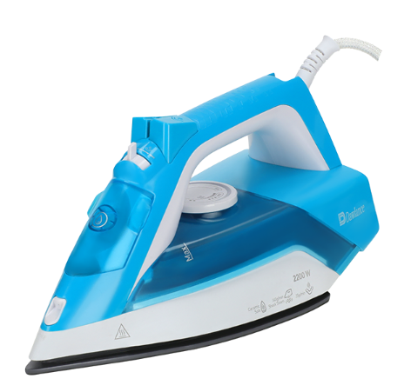

Dawlance Iron
Rs.5,305
Dawlance Steam Iron is a powerful and efficient garment care appliance designed for smooth and fast ironing. It features a ceramic non-stick soleplate, adjustable steam control, and temperature settings that help remove wrinkles from all types of fabrics with ease. The steam and spray functions provide better crease removal while ensuring safe and convenient operation.

Specifications
- Type: Steam Iron
- Power: 1750–2200 Watts
- Capacity: Approx. 220–300 ml
- Temperature Control: Adjustable Thermostat Control (Low to High Heat Settings)
- Color: Blue / White
- Voltage: 220–240 V

Key Features
- High Power Performance (Approx. 1750–2200W)
- Steam & Dry Ironing Functions
- Adjustable Temperature Control
- Ceramic Non-stick Soleplate
- Auto Shut-off Feature
- Vertical Steam Function
- Anti-drip System
- Durable Build with Comfortable Handle

